DevOps summary

1. Continues planning
2. Continues development
3. Continues integration
4. Continues deployment
5. Continues testing
6. Continues delivery and monitoring
7. Continues feedback

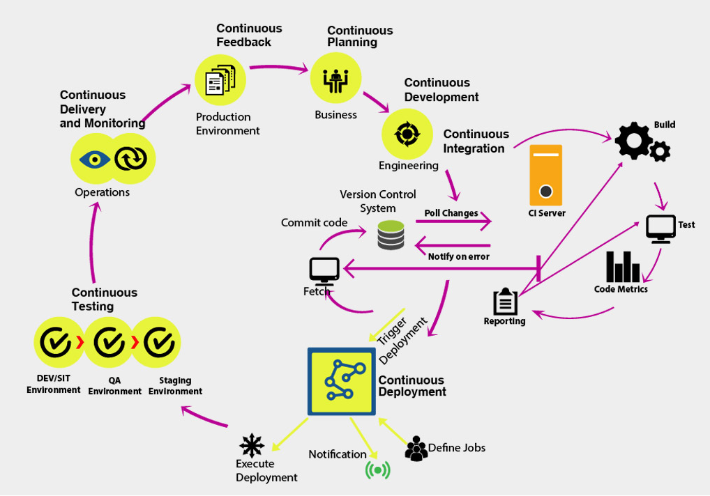

* Devops for mobile, enterprise and cloud
* Infrastructure automation

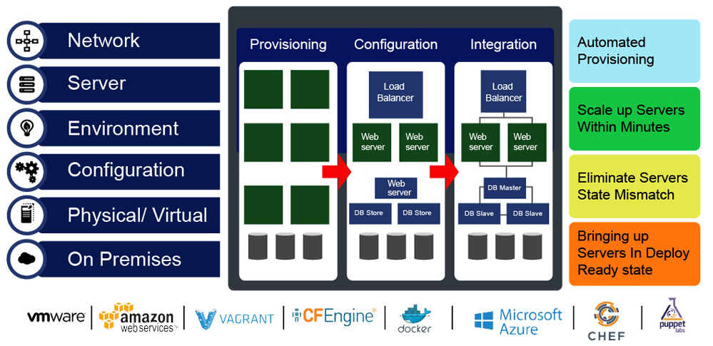

* Code inspection and integration

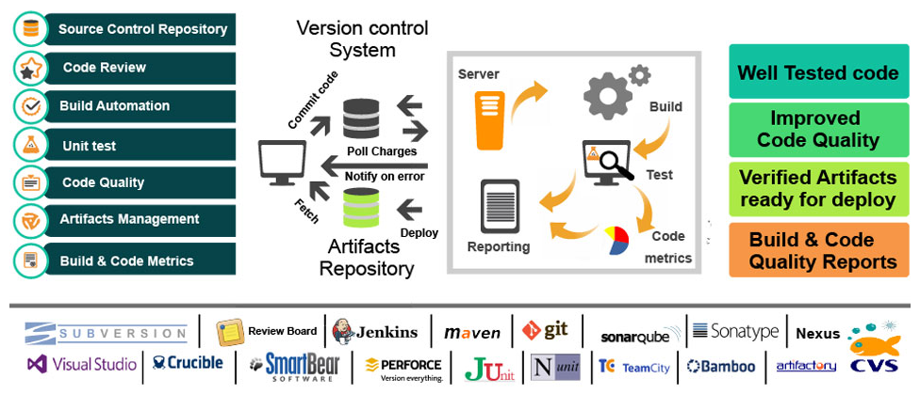

* Configuration Management

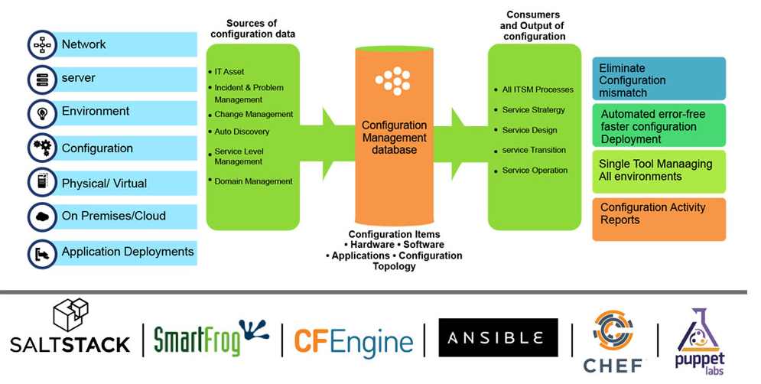

* Deployment automation and orchestration

